**Homework/exam problems**

Xie, S.-P., 2023: [*Coupled Atmosphere-Ocean Dynamics: Climate Variability and Climate Change*](https://www.sciencedirect.com/book/9780323954907/coupled-atmosphere-ocean-dynamics). Elsevier, 424 pages.

**Chapter 2**

2.1. Saturation water vapor partial pressure $e_{s}$ follows the Clausius-Clapeyron (CC) equation

$$\frac{1}{e_{s}}\frac{de_{s}}{dT}=α,$$

where the CC coefficient is a weak function of temperature T in K but is treated here as a constant =0.065 K-1. Assume that the atmospheric relative humidity is constant, say at 0.8. Show the vertical profile of water vapor partial pressure

$$e_{v}=e_{0}\exp\left(-\frac{z}{H_{v}}\right),$$

where $e_{0}$ is the vapor pressure at the sea level, and $H_{v}=1/(αΓ)$ is the scale height for water vapor with $Γ$ as the lapse rate for temperature. Calculate *Hv* with $Γ$ =6.5 K/km.

2.2. Answer the following questions.

1. Wind-driven Ekman flow dominates ocean heat transport in the tropics. Why does the poleward ocean transport of energy peak at 15o latitude? Why does the ocean energy transport decrease poleward from there?
2. Why is the atmospheric Hadley overturning circulation inefficient in the meridional transport of moist static energy?

2.3. The Hadley circulation is a meridional overturning circulation due to the equator-to-pole temperature gradient in the troposphere.

1. Why does the Hadley circulation terminate at 30o latitude, instead of extending all the way to the poles? How role do eastward-moving mid-latitude storms play in inducing the Ferrel cell?
2. With the Hadley and Ferrel cells, explain why the easterly and westerly winds prevail near the surface in the tropics and midlatitudes, respectively.

2.4. Baroclinic instability waves transport heat poleward, $\overline{v^{'}T^{'}}$ >0. Assume that atmospheric relative humidity is nearly constant at 0.8.

1. Show eddy transport of moist static energy $\overline{v^{'}m^{'}}=(1+b_{e})c_{p}\overline{v^{'}T^{'}}$.
2. Calculate $b_{e}=L\overline{q}α/c_{p}$, the inverse Bowen ratio that represents the enhancement due to the latent heat of water vapor. Here L=2.5x106 K/kg is latent heat of condensation, ~5x10-3 kg/kg the mixing ratio of water vapor at midlatitudes, =0.065 K-1 the Clausius-Clapeyron coefficient, and =103 J/K/kg the specific heat at constant pressure.

**Chapter 3**

* 1. The black-body radiation is given by R=T4, where 5.67x10-8 W/m2/K4.

1. What is the infrared radiation an ocean surface of 27oC emits?
2. The typical clear-sky OLR at the top of the atmosphere (TOA) is around 300 W/m2. Why is this lower than the value in (a)?
3. At the tropopause (15 km above the sea level), temperature is about 90 K colder than at the surface. How much infrared radiation the surface of a black body (e.g., clouds) there emit?
4. In the annual-mean climatology, outgoing longwave radiation (OLR) at the top of the atmosphere is about 230 W/m2 in deep convective regions. Assume that the atmosphere varies between deep convective (with cloud top temperatures of 210 K) and clear sky conditions (OLR=300 W/2). What is the percentage of time that the area is in deep convection? Assume binary OLR value of either clear sky or deep convection.
   1. In the tropical troposphere, adiabatic cooling due to vertical motion is to first order balanced by diabatic heating
$$ω\frac{∂s}{∂p}≈Q_{1}$$

5. Verify this statement by calculating the LHS and RHS at 500 mb from the observational results in the figure below. Here the dry static energy *s* is related to potential temperature, $ds=c_{p}Tdlnθ=c_{p}{\left(p/{p_{s}}\right)}^{κ}dθ$, where ps=1000 mb, and k=2/7.
6. Explain briefly why the horizontal advection is negligibly small in the above energy equation in the tropical mid-troposphere.

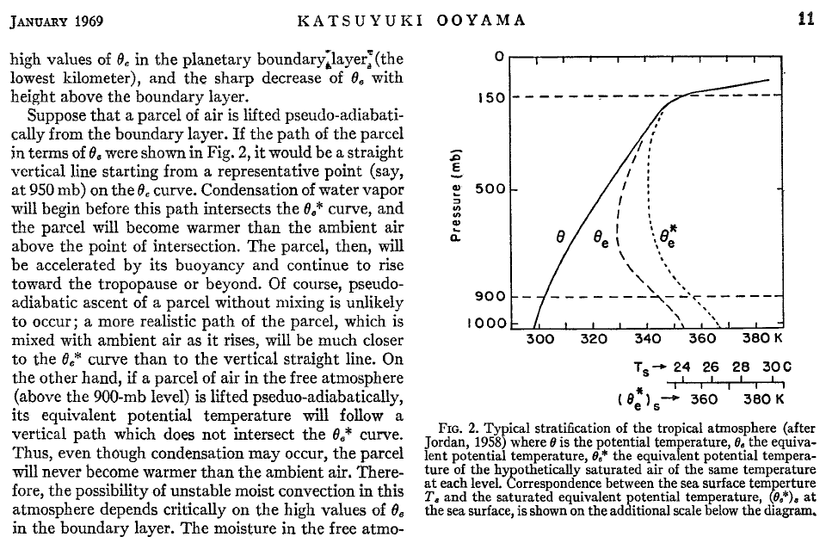

/cp

/cp

/cp

**Figure**. Vertical profiles of (left) potential temperature (K), (middle) pressure velocity (mb/hour), and (right) apparent heat source (Q1/cp, K/day).

* 1. Answer the following questions regarding Q1 and Q2 in Yanai and Tomita (1998, *J. Climate*).

1. Discuss how one can use Q1 and Q2 to infer the mechanisms for diabatic heating in Region E (Bay of Bengal) during June-July-August in Fig. 5 of the paper (section 4).
2. How does rainfall change from summer to winter at this site, judging from the seasonal variation in Q1 and Q2? Is this consistent with OLR observations (Figs. 1 and 3)?
3. Compare Q2 in the boundary layer between Regions A (Africa) and E in Dec-Jan-Feb. 4.

3.4. Consider infinitesimal perturbations on the equatorial beta plane (Eqs. 7.7-9). Set the dissipation coefficient g=0. The Kelvin wave is a solution of v=0 and in geostrophic balance in the meridional direction

$$fu=-g'\frac{∂h}{∂y}$$

a) Show that for the Kelvin wave, $\left(\begin{matrix}u \\ h\end{matrix}\right)=\left(\begin{matrix}\tilde{u} \\ \tilde{h}\end{matrix}\right)exp\left[-{\left(\frac{y}{2R}\right)}^{2}\right]$, where $R=\sqrt{\frac{c}{β}}$ is the Rossby radius of deformation with c2=g’H.

b) Derive the wave equation for thermocline depth perturbation $\tilde{h}$ (x,t). Show that the equatorially-trapped Kelvin wave propagates eastward.

c) Give one example that the Kelvin wave is important for tropical climate.

3.5. Answer questions regarding the Gill model of a baroclinic atmosphere.

1. Calculate the wave speed of the baroclinic mode in Eq. 3.19 using the typical tropical sounding in the above figure. How long does it take for the equatorial Kelvin wave to travel around the globe? Calculate the equatorial radius of deformation.
2. Draw a schematic of the Gill model response to an isolated heat source centered on the equator, and explain the key features, especially regarding the east-west asymmetry.
3. Discuss how the Gill response explains the Walker circulation and prevailing surface winds over the equatorial Indo-Pacific Oceans.
4. Outside the convective region over the equatorial Indo-Pacific, how does the Walker circulation cause tropospheric warming against the radiative cooling?

3.6. Tropical deep convection is confined to warm oceans with SST>27oC. The tropical mean SST is also about 27oC. Is this just a coincidence? Explain how the SST threshold for convection is set?

**Chapter 4**

4.1. Answer the following questions regarding the hierarchy of tropical convective organizations. Refer to Fig. 4.3.

1. In May 1987, two convectively coupled (CC) Kelvin waves travel around the globe. Estimate the longitudinal and time intervals between the two waves, and mark the results on the Wheeler-Kiladis wave number–frequency power spectrum (Fig. 4.2). Discuss if your results are consistent with the long-term statistical analysis.
2. The 30-60 days band-pass filter is often applied to isolate the MJO. Will this filter remove the signals of the above Kelvin wave?
3. Compare the horizontal structure of the CC Kelvin wave and MJO (Figs. 4.4 and 4.7). Discuss major differences.
4. Explain why the CC Kelvin wave travels at a phase speed of 15 m/s, instead of 50 m/s as in Matsuno’s original theory.
5. Discuss evidence for the diurnal cycle of convection over tropical Africa. Does the diurnal convection show coherent zonal propagation? In which direction?

4.2. Refer to Fig. 3 of Hendon and Salby (1994) and answer the following questions related to MJO.

1. Describe the circulation patterns at 850 and 200 mb in relation to the Matsuno-Gill solution.
2. What are the major differences in horizontal structure (wind speed/direction and divergence) between 850 and 1000 mb? What causes the differences? Does this PBL convergence favor an eastward or westward phase propagation of the MJO convective center?
3. The coupled convection-circulation pattern slowly propagates eastward. Discuss what happens when the pattern moves across the international dateline into over the cold ocean surface (refer to Fig. 9 as necessary).

Hendon, H.H., and M.L. Salby, 1994: The life cycle of the Madden–Julian Oscillation. *J. Atmos. Sci.*, **51**, 2225–2237. (Read only section 3.)

**Chapter 5**

5.1. In pre-monsoon May, North Indian Ocean SST is 300K with RH=80%. Relative humidity over India is 50%. What is the surface air temperature over India that matches moist static energy over the North Indian Ocean? The saturation mixing ratio is given by ${q_{s}=q}_{0}exp⁡[α\left(T-T_{0}\right)]$, where q0=2.6x10-2 g/kg, T0=303K, and =0.06 K-1.

5.2. Answer the following questions regarding the summer (JJA) monsoon.

1. Describe the prevailing winds (direction and speed) over India near the surface (925 mb) and in the upper troposphere (200 mb).
2. Where is the upper-tropospheric westerly jet located relative to the Tibetan Plateau? How is the westerly jet related to the prevailing winds above India in the upper troposphere? Hint: the Tibetan High.
3. How well are the above circulation features compared with Gill’s solution to an isolated heat source north of the equator? Discuss briefly what causes this heating? Is the latent heat of condensation important? Refer to Q1 and Q2 distributions in the Indo-western Pacific sector.
4. Shanghai is located on the east coast of Asia at 31oN. The annual rainfall is 1166 mm, most of it occurring in summer. The 31oN latitude cuts through the Sahara Desert. Explain briefly why is the Sahara dry while Shanghai is blessed with summer rains?
5. The Asian summer monsoon heating excites baroclinic Rossby waves that propagate westward. How does this affect summer rainfall to the west including Arabia and Africa? Hint: Consider vertical velocity in the monsoon-induced Rossby waves (the monsoon-desert mechanism).

**Chapter 6**

6.1. In the tropics and subtropics, the SST-cloud feedback may be positive or negative. Explain both the positive and negative feedbacks, and the conditions and geographical preference for each type of SST-cloud feedback.

6.2. Consider an air parcel at the sea level with a relative humidity *RH*. Raise the air parcel in the vertical will cause water vapor inside to condense and form cloud.

1. Show that the cloud base height (lifting condensation level) is

where d is the dry adiabatic lapse rate (9.8 K/km), and H=7.5 km is the pressure scale height, with p0 being sea level pressure. Use the Clausius-Clapeyron Equation

$$e_{s}=e_{s0}exp\left[α\left(T-T_{0}\right)\right]$$

where *e* is water vapor partial pressure, the subscript s denotes saturation, and 5 😐. Assume that the parcel does not mix with the environment as it rises from the sea surface to the cloud base, i.e., *RH* qs(z=0) = qs(z=zc). Here q $=0.062 e/p$ is the specific humidity.

1. Over ocean, relative humidity is about 80% at the surface, what is the typical cloud base height for low clouds?
2. Over land, *RH* can drop to 50% during the day. What is the cloud base height? Discuss how sunlight can burn stratus clouds in coastal San Diego, where the inversion base is typically not more than 1km high.
3. Over the ocean, the diurnal cycle in surface temperature is negligible but the amount of boundary-layer cloud decreases during the day. Explain why. Consider how solar radiation affects turbulent mixing in the marine boundary layer. Consult Wood (2012) section 2.b.5.

**Chapter 7**

7.1. Refer to the right figure and answer the following questions. The figure depicts the thermocline depth displacements on the Pacific coast of Ecuador (80oW) at the equator, in response to an abrupt onset of westerly winds at t=0 in a zonal patch (160oE-160oW) centered at the international dateline. The wind anomalies peak at the equator and gradually decay poleward (corresponding to the movie loop in lecture slides).

1. Why does the thermocline deepen on the Ecuador coast even though it is far away from the region of wind change? How does the sea level vary?
2. It takes 50 days for the thermocline to deepen in Ecuador following the wind onset. Estimate the phase speed of the wave that causes the thermocline to deepen.
3. Why does the thermocline begin to shoal around day 150?
4. The thermocline depth off the Ecuador coast subsequently oscillates at a period of about 400 days (with the amplitude decaying in time). What determines this period of oscillation.
5. What would be period of the sea level oscillation be on the eastern boundary if the ocean basin width is reduced from 150o (Pacific) to 60o (Indian) in longitude? Explain briefly.

**Chapter 8**

8.1. Study feedback of surface evaporation (E) on SST (T) in the off-equatorial ocean. The heat budget of the ocean surface mixed layer is

$ρc_{p}H\frac{∂T'}{∂t}=-LE'$,

where the prime denotes perturbation, =103 kg/m3 is water density, cp=2.5x103 J K-1 kg-1the specific heat of water, and H=50 m the depth of ocean mixed layer. Surface evaporation is given by

E= $ρ_{a}C_{E}\left|\overline{U}+U^{'}\right|\left(1-RH\right)q_{s}\left(\overline{T}+T^{'}\right)$,

where $ρ_{a}$ is air density, CE the drag coefficient, $\overline{U}$ = -10 m/s is the background easterly wind velocity, RH~80% relative humidity, and qs is the saturated specific humidity. Here we assume that other heat flux components do not change, and ignore the surface air-sea temperature difference.

The linearized equation for small perturbations in ocean surface mixed layer temperature is

$$\frac{∂T}{∂t}=aU-bT.$$

Here we have dropped the prime for clarity.

(a) Show that the thermal damping rate due to Clausius-Clapeyron (CC) effect is

$$b=\frac{L\bar{E}}{ρc_{p}H}α,$$

where =150 W/m2 is the mean latent heat flux, =103 kg/m3 water density, cp=2.5x103 J K-1 kg-1the specific heat of water, and H=50 m the depth of ocean mixed layer. Use the Clausius-Clapeyron equation (= ~ 0.065 K-1).

(b) Calculate the CC damping rate *b*. By comparing with the atmospheric damping rate ~ (a few days)-1, make an argument that the atmosphere adjusts to a near-steady state on the timescale of ocean adjustments.

(c) Show $a=\frac{L\bar{E}}{ρc_{p}H}\frac{1}{(-\overline{U})}$.

(d) Consider a two-strip model across the equator. Let  denote the cross-equatorial difference and assume no zonal variations. Compute the WES coupling coefficient ** =*a*, where U=T with =0.5 m/s/K (cross-equatorial wind difference of 0.5 m/s per degree SST difference). Here  denotes the cross-equatorial difference and assume no zonal variations. Compare the effective damping ate (*b-*) with the CC damping rate (*b*).

(e) Consider a symmetric SST perturbation instead that peaks on the equator and is uniform in the east-west direction and discuss the wind response. Is it obvious that the WES feedback will cause the perturbation to grow?

(f) From Fig. 6.10B, estimate the cloud-radiative effect (CRE) on downward shortwave at the sea surface and compare with the CC damping rate in (b). In Fig. 6.10B, R at the bottom right is the shortwave CRE regression against local SST variability.

**Chapter 9**

9.1. Choose one most appropriate answer in brackets and *Italic* in the following multiple-choice questions.

a) What are the typical values of annual-mean sea surface temperature (SST) in the western equatorial Pacific (near Indonesia) and at the Galapagos islands in the east? Explain briefly (in 2-3 sentences) what causes this east-west difference.

b) At the Galapagos in the east equatorial Pacific, SST is warmest in [*September, March, June*]. Explain your answer briefly.

c) If temperature at 500 hPa above the Galapagos is 268K, temperature at the same pressure level is about [*268, 278, 258*] K in Indonesia. Explain your choice briefly.

d) When SST at the Galapagos is anomalously high, what wind anomalies do you expect at the international dateline? Explain briefly the connection.

9.2. Compare the annual cycle and interannual variability at the Galapagos.

1. Through a typical year, the thermocline depth (Z20) hardly varies but the SST shows a marked annual cycle. What causes the SST annual cycle?
2. During El Nino, the zonal wind hardly changes but both the SST and sea level rise. Discuss the cause and key mechanisms.

9.3. When SST near the Galapagos (90oW, equator) is anomalously high, what wind anomalies do you expect at the international dateline, equator? How about local sea level height at the Galapagos? Explain briefly the connections.

9.4. Wyrtki (1975) noted that winds off Peru hardly change but SST rises sharply during El Nino.

1. What causes the eastern equatorial Pacific warming?
2. Sea level decreases at American Samoa (170oW, 14oS) during El Nino. Explain why.

9.5. Based on Fig. 12.8 of *interannual* variance, answer the following questions.

a) Why is SST variance much smaller in the western than eastern equatorial Pacific?

b) At 90oW, equator, the interannual zonal-wind variance is small. Is the sea level variance low as well? Are the SST and sea level anomalies related to each other?

c) Interannual SST variance is about the same at 160oW and 90oW in the equatorial Pacific. Estimate the depth of the 20oC isotherm depth at 160oW in December 1997 and December 1998. Based on the transect of ocean temperature anomalies in December 1997, discuss why the thermocline depth change is not the major mechanism for SST warming at this site.

d) Zonal wind variability is large at 160oW. Discuss how the local wind variability might be important in driving SST variability at this site. Refer to the perturbation SST equation (9.3) as necessary.

9.6.Refer to section 9.4.4 and answer the following questions regarding ENSO diversity.

1. In which season does Nino3 SST variability tend to peak? On average, what do you expect Nino3 SST anomalies to evolve through Feb-Mar-Apr (FMA)?
2. EOF analysis of FMA precipitation variability over the eastern tropical Pacific yields an extreme El Nino and a moderate ENSO mode. Compare the atmospheric anomalies between the two modes.
3. Qualitatively, how does the extreme El Nino differ from the canonical El Nino Wyrtki (1975) described in terms of zonal wind anomalies near the equator? Speculate how these “local” wind anomalies might contribute to the evolution of the SST anomalies in Nino3 region?

(Several versions of the problems on current conditions of the tropical Pacific are given in the following. For example, 9.7 is appropriate when clear ENSO conditions develop.)

9.7. NOAA maintains a website that updates the current conditions of the tropical Pacific

<http://www.cpc.ncep.noaa.gov/products/precip/CWlink/MJO/enso.shtml>

The weekly ppt file offers a summary of the updates:

<http://www.cpc.ncep.noaa.gov/products/analysis_monitoring/lanina/enso_evolution-status-fcsts-web.ppt>

1. Describe current Pacific oceanic conditions (SST and thermocline depth anomalies).
2. Describe current atmospheric conditions over the Pacific (OLR and 850 hPa wind).
3. Are these ocean and atmospheric anomalies reinforcing each other? From when have the atmospheric anomalies begun taking shape? Such persistence is part of evidence that atmospheric anomalies are forced/coupled with ocean, not due to transient perturbations.
4. What do models predict? Evaluate based on these model predictions the merit of the claim that we are going to have a super El Nino in December.
5. What is your prediction for rainfall of the coming winter in California? List two other regions where you expect major climatic anomalies for the next year.

9.8. The National Centers of Climate Prediction (NCEP) archive monthly [Climate Diagnostics Bulletin](http://www.cpc.ncep.noaa.gov/products/CDB/CDB_Archive_pdf/PDF/CDB.oct2015_color.pdf) (click the link to the October 2015 issue). Use figures in the bulletin to answer the following questions regarding the 2015-16 El Nino event. Include in your answer 1-2 figures for each question as necessary.

1. Describe major ocean-atmospheric anomalies (SST, OLR/precipitation, 850 hPa winds, and the thermocline displacements) over the tropical Pacific in October 2015. How did these anomalies form a positive coupled feedback to grow this El Nino event?
2. Discuss the evidence and reason for the east-west difference in thermocline feedback on SST in the equatorial Pacific (Fig. 17).
3. Near the international dateline, ocean temperature anomalies feature a vertical dipole between the surface warming and subsurface cooling. What are the mechanisms causing the surface warming there?
4. Why was a transition to La Nina predicted as early as in March 2016? Discuss oceanic conditions at the time that support this prediction. Do the current observations (April or May 2016 issue) verify the prediction?
5. Ocean-atmospheric conditions show signs of a weak Indian Ocean dipole mode. Discuss SST, rainfall, zonal wind, and thermocline depth anomalies that are suggestive of a positive Bjerknes feedback over the equatorial Indian Ocean.

9.9. The NOAA Climate Prediction Center archives monthly [*Climate Diagnostics Bulletin*](https://www.cpc.ncep.noaa.gov/products/CDB/CDB_Archive_html/bulletin_112020/Tropics/figt15.shtml) (link to the November 2020 issue). Use figures in the *Bulletin* to answer the following questions regarding the state of the tropical Pacific in November 2020. Include in your answer 1-2 figures for each question as necessary.

1. Describe major ocean-atmospheric anomalies (SST, OLR/precipitation, 850 hPa winds, and the thermocline displacements) over the tropical Pacific.
2. How might these anomalies form a positive coupled feedback for mutual growth?
3. Discuss the evidence and reason for the east-west difference in the thermocline feedback on SST in the equatorial Pacific (Fig. 17 bottom).
4. Evaluate the NCEP coupled model (CFS.v2) forecast of Nino3.4 SST issued in June 2020 (figure below). Discuss what in the initial conditions might contribute to the forecast skill. Hint: Time-longitude sections in the November 2020 issue of the *Bulletin*.

**Figure.** Predicted and observed sea surface temperature (SST) anomalies for the Nino 3.4 region (5N-5S, 170W-120W) from the NCEP Coupled Forecast System Model (CFSv2). The forecasts consist of 40 forecast members. The ensemble mean in the thick blue line, individual members in thin lines, and the observation is indicated by the thick black line.

**9.10**. La Nina conditions prevail during much of 2022 so far. Refer to *Climate Diagnostics Bulletin* April 2022 ([Tropics/Mean & Anomaly Fields](https://www.cpc.ncep.noaa.gov/products/CDB/CDB_Archive_html/bulletin_042022/Tropics/figt16.shtml)).

a. List anomalies of April 2022, one type each for the ocean and atmosphere, that are indicative of La Nina.

b. The April precipitation climatology is nearly symmetric over the eastern tropical Pacific, with one ITCZ on either side of the equator. The southern ITCZ failed to develop in [April 2022](https://www.cpc.ncep.noaa.gov/products/CDB/CDB_Archive_html/bulletin_042022/Tropics/figt26.shtml). Explain why based on the SST anomalies.

c. Discuss the mechanism for [equatorial SST anomaly](https://www.cpc.ncep.noaa.gov/products/CDB/CDB_Archive_html/bulletin_042022/Tropics/figt17.shtml) around the international dateline. Refer to [surface currents](https://www.cpc.ncep.noaa.gov/products/CDB/CDB_Archive_html/bulletin_042022/Tropics/figa1.3.shtml) as necessary.

d. Discuss how La Nino might have contributed to the dry conditions on the California coast.

(Assigned in June 9, 2023.)

9.11. NOAA Climate Prediction Center (CPC) reports that the equatorial Pacific is currently in an ENSO neutral state but predicts an El Nino that peaks late this year. For questions a and b, refer to the [CPC website](https://www.cpc.ncep.noaa.gov/products/precip/CWlink/MJO/enso.shtml).

a) Upper-ocean heat content (OHC) refers to the vertically integrated temperature in the upper 300 m. Draw a schematic and show that OHC variability is closely related to that in thermocline depth, say as represented by the 20oC isotherm depth.

b) Describe current subsurface temperature anomalies across the equatorial Pacific. Do the basin-scale pattern of the anomalies project strongly on EOF1 or EOF2 of Fig. 9.15 at the equator? Discuss how the subsurface ocean temperature anomaly pattern may have contributed to NOAA’s El Nino prediction.

c) NOAA National Hurricane Center predicts a near-normal Atlantic hurricane season for 2023 with 12-17 named storms. The prediction is based on both ENSO conditions and unusually warm North Atlantic SSTs. Explain the rationale behind the prediction.

9.12. The Galapagos Islands are located at 90oW, Equator. Sea surface temperature (SST) there is 21oC in September and 26.5oC in March.

1. In 1997, the cold season never developed at the Galapagos, and SST remained above 26oC year-round. Discuss the thermocline depth change near the islands in September 1997, and how it affected SST.
2. Discuss atmospheric anomalies that created the thermocline response in the eastern equatorial Pacific. How might oceanic anomalies affect the tropical atmosphere?
3. If you are asked to forecast interannual variability in Galapagos climate at one season lead, what observations would you consider, and why?

9.13.The dispersion relationships of barotropic Rossby waves in a mean westerly flow ($\overline{u}$ =17 m/s) are given by

$ω=\overline{u}k-βk/K^{2}$ for *barotropic* waves

where , and =1.5x10-11 m-1s-1. (*k*, *l*)=2p(1/Lx, 1/Ly), where (Lx, Ly) are the zonal and meridional wavelengths.

1. Calculate the stationary wavenumber for barotropic Rossby waves. Compare with the PNA pattern. You may evaluate the total wavenumber from the wavelengths normal and along the great circle of the energy propagation.
2. Discuss how the PNA pattern affects the North Pacific westerly jet and weather/climate in California during El Nino winters.
3. Sea level often rises off La Jolla during a major El Nino event. Is this a direct effect of the PNA teleconnection? If not, identify the cause.
4. How does the PNA affect the tropical Atlantic? How might this help predict rainfall in northeast Brazil?

**Chapter 10**

10.1. The first EOF of interannual rainfall variability over the tropical Atlantic during March-April represents an anomalous meridional shift of the ITCZ. What SST pattern is associated with this rainfall mode? Describe briefly the ocean-atmospheric feedback for this mode.

10.2. Northeastern Brazil (Nordeste region) is a semi-arid region that receives rainfall during the boreal spring when the Atlantic ITCZ moves south.

1. Which two predictors would you include in building an empirical prediction model for February-April rainfall over northeastern Brazil? Hastenrath & Greischar (1993, *J Climate*)
2. Briefly justify your choice and explain ocean-atmospheric feedbacks that give rise to the predictability.

10.3. Answer the following questions regarding tropical cyclones.

1. List three environmental variables that are important for tropical cyclone activity.
2. Explain briefly how upper ocean thermal structure might affect tropical cyclone intensity.
3. For the same atmospheric conditions, why is a fast-moving cyclone more likely to attain higher intensity than a slow-moving one?
   1. Answer the following questions regarding North Atlantic hurricane activity.
4. How does ENSO affect North Atlantic hurricanes? Use the Gill model to explain the response of the vertical wind shear in the main development region to ENSO and discuss the effect on tropical cyclogenesis.
5. NOAA predicted 14-21 named storms for the 2022 hurricane season, compared to the long-term average of 14. This outlook follows a period of heighted hurricane activity: 21 and 30 named storms in 2021 and 2020, respectively. Evaluate the argument that the strengthened Atlantic hurricane activity is due entirely to anthropogenic climate change. While global surface warming over the recent half century is due to increased emissions of greenhouse gases, spatial pattern of the greenhouse warming over tropical oceans remains uncertain.



**Fig. 1.** Annual-mean climatological precipitation (white contours at 2 mm/day intervals; shade > 4 mm/day), and SST (black contours at 1oC intervals; only contours for 27oC and above are plotted).



**Fig. 12.8.** Root-mean-square variance of interannual SST anomalies, based on the Reynolds dataset for 1982-2000. Contour intervals are 0.1 (0.2) oC for values smaller (greater) than 0.6 oC. Light (dark) shading denotes values greater than 0.6 (1.0) oC.

10.5. Based on the above figures, answer the following questions.

a) Draw schematically surface wind vectors over all three equatorial oceans. Explain briefly the physical basis for your schematic.

b) Draw schematically the zonal distribution of the thermocline depth along the equator. Explain briefly the physical basis for your schematic.

c) Why does SST variance reach a maximum in the eastern equatorial Pacific and Atlantic? Refer to Fig. 12.8 of *interannual* variance.

d) Describe ocean-atmosphere interaction mechanism that gives rise to the maximum in SST variance in the eastern equatorial Pacific.

e) Why is SST variance in the eastern equatorial Pacific greater than in the equatorial Atlantic? Why is the SST variance smallest in the equatorial Indian Ocean?

10.6. Refer to Fig. 10.11 below and answer the following questions regarding ENSO and the Pacific-North American (PNA) pattern.

1. On the 200 hPa map, mark the PNA’s four centers of action and likely path for energy propagation of the atmospheric stationary wave train.
2. On the surface map, how does the PNA circulation contribute to elevated sea levels during El Nino winters on the U.S. west coast?
3. How does ENSO affect California precipitation? Table 1 shows that precipitation at San Diego for the recent five years (the 2023 water year is provisionary). Is ENSO the only driver for PNA variability? Is the non-ENSO variability predictable one season in advance? Briefly explain.
4. The tropical North Atlantic is known to experience anomalous surface warming in the March-April-May season following El Nino. Discuss briefly how the PNA contributes to this tropical Atlantic response through wind-induced evaporation change.

**Fig. 10.11**. ENSO-induced anomalies as regressions against DJF Nino3.4 in concurrent DJF. (A) SST (oC; shading) and surface wind (m/s; vectors); (C) streamfunction (contours with ci = 1 x 106 m2 /s) and rotational wind (m/s; vectors) at 200 hPa.

**Table 1**. Water-year precipitation (inches) at San Diego International Airport and DJF Nino3.4 SST index (oC) within the water year. Water year 2023 refers to October 2022-September 2023.

|  |  |  |  |  |  |
| --- | --- | --- | --- | --- | --- |
|  | 2019 | 20 | 21 | 22 | 23 |
| Precipitation (in) | 12.9 | 13.6 | 5.24 | 6.75 | (13.9) |
| Nino3.4 (DJF, oC) | 0.7 | 0.5 | -1.0 | -1.0 | -0.7 |

**Chapter 11**

11.1. Answer the following questions comparing the equatorial Indian and Atlantic Oceans.

a. Over the equatorial Indian Ocean, the meridional advection of easterly momentum causes the zonal wind to attain a semi-annual cycle. Consider a uniform southerly flow near the equator to mimic the NH summer monsoon. Draw the meridional profile of zonal wind induced by the Coriolis force. Now let the meridional advection of momentum kick in. Which direction will the resultant zonal wind be on the equator? What about the zonal wind on the equator during NH winter when the cross-equatorial wind is northerly?

b. Over the equatorial Atlantic, why does the meridional momentum advection induce an annual cycle in zonal wind? Hint: meridional asymmetry in the mean state.

11.2. Compare the seasonal cycle of equatorial zonal wind in the Indian and Pacific Oceans. Discuss the cause of the zonal wind cycle, and relationship (or the lack thereof) to the SST seasonal cycle.

* 1. Answer the following questions regarding the Bjerknes feedback.

1. Compare the Bjerknes mode in each of the three tropical basins and its influence on rainfall in the basin and possibly beyond.
2. Why is the Bjerknes mode in the Atlantic and Indian oceans not as energetic as in the Pacific, say in SST variability?
3. Why is the mode not expected in the tropical Indian Ocean from its annual-mean climatology? Which season is the mode locked in phase? Why?

11.4. Guam (13°28′N 144°45′E) is located in the tropical Northwest Pacific. Summer (JJA) rainfall there tends to decrease in post-El Nino summers (e.g., in 1998). Summer rainfall at Guam is more highly correlated with Nino3.4 SST in the antecedent winter (NDJ) than in the concurrent summer (*r* = -0.4 vs. +0.35 over 63 years of 1945-2007).

1. What is the large-scale recurrent pattern of the summer anomalous atmospheric circulation, of which Guam rainfall variability is part?
2. Describe the most robust SST anomalies over the Indo-Pacific Oceans concurrent with decreased Guam precipitation in summer.
3. Explain how positive feedback from regional ocean-atmospheric interactions might help maintain the coupled ocean-atmospheric anomalies over the Indo-western Pacific region in post-El Nino summers.

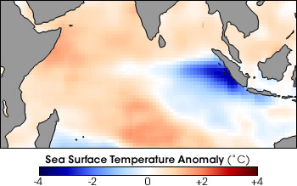

**Upper panel**: Climatological sea level pressure and surface wind vectors in JJA. **Lower panel**: SST anomalies in a month of 1997.

11.5. The figure above shows the climatological surface wind and SLP distributions during June-August (JJA). Answer the following questions.

1. What are the prevailing winds above India at 200 hPa? Why are tropical cyclones never observed during JJA over the Indian Ocean?
2. Zonal winds are weak over the equatorial Indian Ocean (compared to the Pacific). From the winds, infer the thermocline depth distribution across the equatorial Indian Ocean. The traditional view was that the equatorial Indian Ocean is not conducive to an ENSO-like zonal mode of interannual variability. Explain why?
3. Then in 1997, an equatorial cold tongue developed from the Indonesian coast (lower panel of the figure). Discuss rainfall anomalies near Indonesia and zonal wind anomalies over the equatorial Indian Ocean, and how the interactions with the ocean would generate positive feedback to amplify the SST cooling off Indonesia.
4. The alongshore winds are southeasterly only during June-October off the west coast of Indonesia south of the equator. How does this seasonal variation in alongshore winds affect thermocline feedback? In which season is interannual SST variability largest in the region? Thermocline feedback refers to the effect of thermocline displacements on SST.

11.6. The quasi-steady shallow water equations represent a linear approximation of the low-level flow (u,v) of the atmosphere

Here  is geopotential, =df/dy=2.28x10-11 s-1m-1, c is the phase speed of the baroclinc Kelvin wave, and  is the damping rate. Answer the following questions regarding Indian Ocean climate. In questions a-b, assume that the flow is zonally uniform (or represents the zonal mean).

a) Show that the zonal flow is zero at the equator for the zonal mean linear solution.

b) The Asian-Australian monsoon system drives a cross-equatorial flow that reverses the direction between the boreal summer and winter. Show that this cross-equatorial flow advects easterly momentum at the equator in both summer and winter, either using schematics or deriving the second-order correction to the linear solution.

c) Describe and briefly explain the seasonal variations of zonal surface wind and ocean surface current in the equatorial Indian Ocean in the figure below.

d) The resonance of equatorial waves with the wind forcing is considered important for the pronounced Wyrtki jets (the intense eastward surface ocean current) in the equatorial Indian Ocean. What is the Kelvin wave speed that resonates with the semi-annual zonal wind forcing in the Indian Ocean basin (the zonal width=6,000 km)?

e) In November 1997 as a major El Nino event developed in the Pacific, the fall Wyrtki jet was not observed in the equatorial Indian Ocean. Discuss the likely patterns of zonal wind and SST anomalies in the equatorial Indian Ocean.

f) Discuss ocean-atmosphere interactions that produced this anomalous event in the Indian Ocean.

g) By contrast, the spring Wyrtki jet is robust and recurs reliably every year. Discuss the cause of this difference in interannual variability between the spring and fall Wyrtki jets.



Calendar month

0.2

-0.2

-0.6

-0.2

Figure. Zonal wind stress (N/m2, left panel) and zonal ocean surface current (cm/s, right) in the equatorial Indian Ocean as a function of longitude and calendar month.

11.7. Choose a place from the list: *Nagpur, India; Jakarta, Indonesia; Lima Peru; Guam, Northwest tropical Pacific*. Describe the seasonal variations in temperature and precipitation (data and graphs available at <https://en.climate-data.org/>) and a mode of interannual variability that is important for your chosen location. Discuss how coupled ocean-atmosphere interactions might be important.

**Chapter 12**

12.1. The SST-wind speed cross-correlation in Region A is (-0.4, -0.6, -0.4) for lags (-1, 0, 1) (lag -1 means the atmosphere lagging by one month). The correlation is Region B is (0, -0.4, -0.6). Which region has a stronger oceanic feedback to the atmosphere? Briefly explain why. Assume that wind-induced surface flux is the dominant mechanism for SST variability.

12.2. The SST-*zonal wind* velocity cross-correlation in Region A is (0.4, 0.6, 0.4) for lags (-1, 0, 1) (lag -1 means atmosphere lagging by one month). The correlation is Region B is (0, -0.4, -0.6). Assume that wind-induced surface flux is the dominant mechanism for SST variability.

1. Which region has a stronger oceanic feedback to the atmosphere? Briefly explain how the above correlations support your conclusion.
2. Which region is in the trade wind regime, and which in the midlatitude westerly regime? Explain briefly how the atmospheric response to SST variability is fundamentally different between the regions.

12.3. Atmospheric variability (e.g., SLP) can be generally decomposed into the SST-forced and internal components. In the extratropics, stationary variability is barotropic in the vertical.

1. Where in the midlatitudes is the SST-forced variability high? Briefly explain the mechanism. Where is internal variability large? Give one example each.
2. It is early November, and a big energy trading firm needs a winter-season temperature forecast for the southwestern U.S. and for central Europe. This firm turns to you for the forecasts. What factors would you consider in order to generate your forecasts? On average, do you expect your southwestern U.S. forecast or central Europe forecast to have more skill?

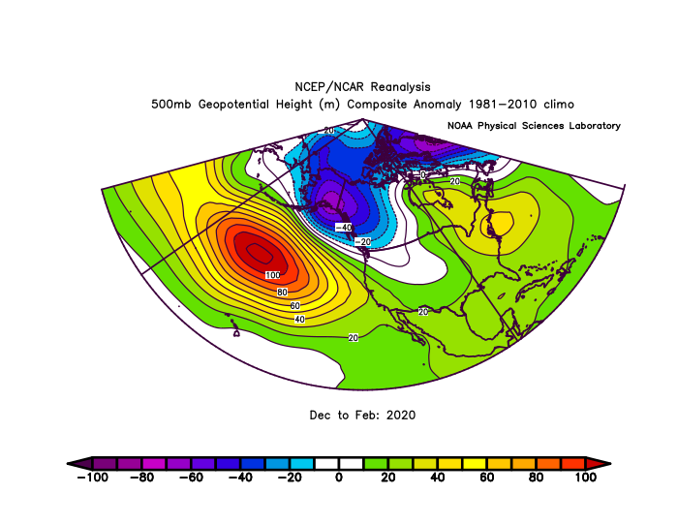

12.4. Answer the following questions regarding *stationary* circulation anomalies (as defined as monthly/seasonal means).

a) Why are stationary anomalies baroclinic in the deep tropics (e.g., the Walker circulation) but barotropic in the winter midlatitude westerly mean flow (e.g., the PNA pattern in the above figure).

b) Why stationary waves are impossible in an easterly mean flow in the midlatitudes.

12.5. Refer to the figure below and answer the following questions.

1. Discuss how wind anomalies drive sea surface temperature (SST) variability in the North Atlantic. Consider latent and sensible heat fluxes and Ekman current advection. Note the apparent correlation between zonal wind and SST anomalies.
2. Why can one conclude that there is a positive feedback from ocean-atmosphere interaction in the deep tropics? Discuss the feedback.
3. Discuss the response of the Atlantic ITCZ, and the possible effects on rainfall over northeastern Brazil (40oW, 5oS). Explain why the response of northeastern Brazil rainfall response is most pronounced in February-April season.
4. Discuss why one cannot conclude from the figure below that there is positive feedback between the ocean and atmosphere over the extratropical Atlantic. Discuss fundamental differences in atmospheric response to SST perturbations in the tropics vs. extratropics.
5. Based on the wind anomalies in the figure, speculate why the mid-latitude (30-45oN) SST anomalies are westward intensified. How might the western boundary current respond to the wind variability?

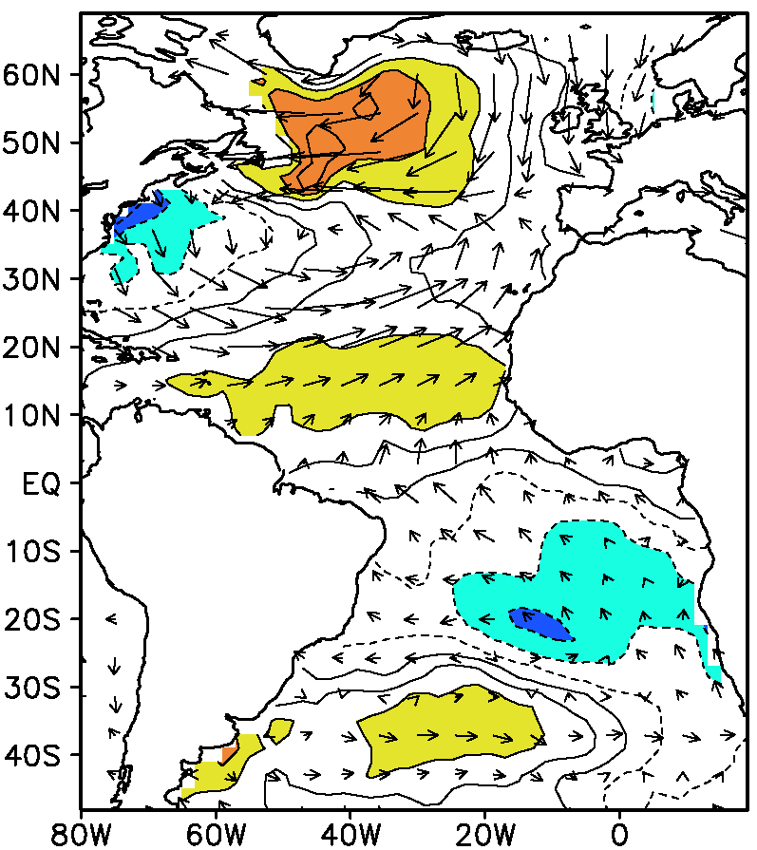

a) SST & wind

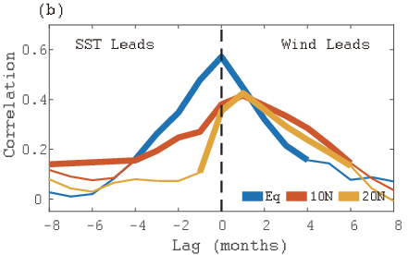

**Figure**. (a) Regression of SST (contours, negative dashed) and surface wind velocity (vectors) against a tropical meridional mode index. (b) Lagged correlation between SST and zonal wind variability at 20oN (orange curve) and 10oN (red); cross-equatorial SST difference (10oN-10oS) and meridional wind at the equator (blue). Anomalies are zonally averaged across the Atlantic basin before the analysis (1979-2017). Correlation exceeding 95% significance thickened. (b) Adapted Fig. 12.6b.

12.6. Refer to Fig. 10 of Adames and Wallace (2014, *J Climate*). Different panels correspond to various phases of MJO with the red dot marking the active convection. When the MJO convection is over the maritime continent, a negative PNA pattern develops (the mid-panel of Fig. 10).

a) Show that the PNA zonal wind anomalies allow large barotropic conversion ($-\overline{{u^{'}}^{2}}\frac{∂\overline{u}}{∂x}$, Eq. 9.15) at the westerly jet exit.

b) While the MJO convection in the tropics propagates eastward, the PNA pattern it excites seems largely stationary, as illustrated by Figs. 9.25 and 4.13. Explain this conundrum. What in the mean state anchors the PNA geographically?

12.7. Lagged correlations with the PNA index for 1950-2020 (positive lag means that PNA leads). PDO is defined based on EOF analyses of monthly SST poleward of 20oN in the Pacific basin. See <https://psl.noaa.gov/gcos_wgsp/Timeseries/> for definitions.

|  |  |  |  |
| --- | --- | --- | --- |
| Lag (month) | PNA | Nino3.4 | PDO |
| -1 | 0.23 | 0.29 | 0.2 |
| 0 | 1 | 0.28 | 0.41 |
| 1 | 0.23 | 0.25 | 0.43 |

a) From the table, infer the relationship between PNA and ENSO. Does this explain the finite auto-correlation at lag 1?

b) At zero lag, the PNA is more highly correlated with PDO than with Nino3.4. Does this necessarily mean that extratropical North Pacific SST anomalies are more influential on PNA than ENSO is? Explain briefly how the lagged correlations help you decide.

c) Design atmospheric model experiments to test your answers above.

12.8. A blob of positive SST anomalies is created in the subtropical Northern Hemisphere (say, centered at 20oN) with the background northeast trade winds.

(a) Sketch the low-level atmospheric pressure and wind velocity response to this warm blob. The equatorial Kelvin wave response is negligible for the SST forcing outside one radius of deformation away from the equator.

(b) Invoke the subtropical wind-evaporation-SST (WES) feedback to argue that the coupled SST and wind anomalies initiated by the blob propagate southwestward, as in the case of the Pacific meridional mode.

12.9. The meridional energy transport by the tropical atmospheric overturning (Hadley) circulation may be written as $\left(m_{u}-m_{l}\right)V$, where V is the mass transport in the upper limb of the overturning circulation, $m_{u}$ and $m_{l}$ are moist static energy of the upper and lower troposphere, respectively. Answer the following questions.

1. Explain why $\left(m_{u}-m_{l}\right)$ is small in the tropics. Confirm that $\left(m_{u}-m_{l}\right)$ is positive, referring to the annual-mean atmospheric energy transport at 10oS and 10oN calculated from observations (Figs. 2.10-11).
2. Explain how the heat transport by the Atlantic meridional overturning circulation (AMOC) causes the zonal-mean ITCZ to displace north of the equator. Discuss how the small $\left(m_{u}-m_{l}\right)$ makes the ITCZ position very sensitive to cross-equatorial ocean heat transport.
3. Why did the ITCZ shift anomalously southward when the AMOC shut down temporarily during Heinrich events (with large ice-sheet discharges into the North Atlantic)?

**Chapter 13**

13.1. Discuss why the following statement is flawed: “In global warming, tropospheric temperature increase amplifies upward. As the troposphere becomes more stable, tropical rainfall will decrease.”

13.2. Climate skeptics often argue: how can you predict climate when you cannot even forecast weather two weeks from now?

1. Refute this argument using the example of predicting El Nino a season in advance. Explain the difference in the mechanism for predictability between weather and ENSO.
2. The limit on the lead time for ENSO prediction is about a year. Why do scientists believe that they can predict certain aspects of future climate (e.g., global mean surface temperature) at the end of the century? What gives rise to the predictability?

13.3. The curve of global mean surface temperature (GMST) shows a prominent rising trend since around the 1970s. Interannual variability is also obvious, superimposed on the rising trend. Specifically, GMST tends to rise in the year following El Nino (e.g., 1998 and 2016). Based on the GMST time series alone, we cannot rule out the possibility that the trend over the past 50 years might be due to some unknown modes of centennial and longer timescales. Explain, say to your parents, why the spatial pattern of the observed warming over the globe can rule out the possibility of naturally occurring variability internal to the climate system.

(Left) Annual-mean GMST as a function of time. (Right) Surface temperature change over 1901-2010. Grid points without sufficient data are left blank.

13.4. Answer the following questions regarding atmospheric circulation change in warming climate.

a) How does the rate of increase differ between global water vapor content and global-mean precipitation? What does this difference imply for the change of the atmospheric overturning circulation?

b) Indeed, most climate models project a slowdown of the Walker circulation and northern Hadley cell, but not the southern Hadley cell (Fig. 13.15). Discuss the coupled SST-wind pattern in CMIP6 multi-model projections (e.g., Fig. 14.4) might explain this discrepancy from the simple theoretical prediction.

**Chapter14**

14.1. The tropical Indian Ocean basin mean SST is currently used to track the IPOC mode that is important for predicting Asian summer monsoon variability (section 11.5). The basin-mean SST index shows an increasing trend since 1950.

1. Does this mean that El Nino becomes less important for the IPOC mode and Asian summer monsoon in warming climate?
2. If you were a forecaster for summer rainfall in the Yangtze River basin, do you rather use the Indian Ocean basin-mean SST detrended or relative to the tropical mean? Why?